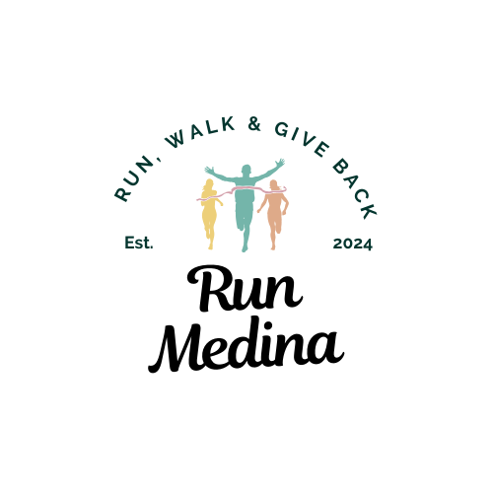**Scholarship Application**

The Run Medina $500 Scholarship is awarded to two deserving high school seniors in Medina County who demonstrate excellence in running, community service, and academic efforts. This scholarship recognizes students who are committed to making a positive impact in their school and community, as well as those who have shown dedication to the sport of running. *Runners of all levels and abilities are welcome to apply. (More Details on last page)

### **Application Requirements:**

* Open to seniors residing in Medina County, Ohio
* Must have participated in running events, including but not limited to cross-country, track, or distance running, local 5K running/volunteering.(2 years minimum on HS team)
* Must demonstrate leadership and service within their school or community
* Must have a minimum GPA of 3.0
* A coach, teacher, or counselor recommendation form is required.
* Please email your completed application to [medinaHalfMarathon@gmail.com](mailto:medinaHalfMarathon@gmail.com) by April 1st at 11:59 PM.

### **Applicant Information:**

**Full Name:** _________________________________________________  
**Address:** __________________________________________________  
**Phone Number:** _____________________________________________  
**Email Address:** _____________________________________________  
**High School:** _______________________________________________  
**Graduation Year:** ____________________**GPA (Current):** __

Intended plans after graduation: (College/athletics/major, etc.)

**Essay Question:** *What does running mean to me? (Answer in less than 500 words)*

. Your essay should address the following topics:

* Your personal experiences with running and how it has impacted your life
* How running has helped you develop discipline, perseverance, and leadership
* The role running plays in your personal goals and future aspirations
* How running connects to your commitment to community service and making a positive difference
* The essay should be free of grammatical errors and your own work/words.
* Attach as a PDF to email when applying.
* Please name your file with your full name and ESSAY

### **Experience and Involvement:**

**Running Experience (Please include events, years of participation, and any achievements):**

**Community Service Involvement (Please describe your community service efforts and any leadership roles): (We understand you are a busy student/athlete, list what you can)**

**Academic Performance (GPA, Honors, or other notable achievements):**

**School and Coach Information:**

**School Name:** ______________________**Coach Name:** _______________________  
**Coach Contact Information:** ___________  
**Other Teacher/Counselor Reference *(if applicable):*** _______________________

(Please forward reference to your coach/teacher/etc.).

### 

### 

### **Coach/Teacher/Counselor Reference Form:**

**To be completed by your coach, teacher, or counselor and returned via email to [medinaHalfMarathon@gmail.com](mailto:medinaHalfMarathon@gmail.com) by April 1st.

**Applicant's Name:** ________________________

**Your Name:** __________________________ **(Coach/Teacher/Counselor/Other)**

**School:** _______________________________**Email Address:** _________________________

**Please rate the applicant in the following areas based on your observations:**

Use a 1-5 Scale with 5 being the best.

|  |  |  |
| --- | --- | --- |
| **Area** | **Rating**  **(1-5)** | **s** |
| **Academic Performance** | 1 2 3 4 5 |  |
| **Effort and Commitment to Running** | 1 2 3 4 5 |  |
| **Leadership/Teammate Role** | 1 2 3 4 5 |  |
| **Community Service Impact** | 1 2 3 4 5 |  |
| **Overall Character and Integrity** | 1 2 3 4 5 |  |

**Additional Comments:**

Signature: ___________________________________________________- Date: _____________

### 

### **Application Deadline:**

All applications, including essays and reference forms, must be submitted by **April 1st.**

### **Submission Instructions:**

* Submit the completed application form along with your essay to:  
  **Run Medina Scholarship Committee to** [**medinaHalfMarathon@gmail.com**](mailto:medinaHalfMarathon@gmail.com)
* Please have your coach, teacher, or counselor submit their reference form directly to the scholarship committee by the deadline. (Via email)
* Winners will be directly notified by June 1st and posted to our social media for the Medina Half Marathon/Run Medina.

Good luck, and thank you for applying for the Run Medina $500 Scholarship!

Your dedication to running, academic success, and service to the community, is truly commendable.

Please note this is the former, Medina County Road Runners Scholarship. The runners are no longer members of the Road Runner Organization. We have blended with the Medina Half Marathon–Run Medina is our new 501c3 and the provider of the funds for this event. Funds raised from the Annual Medina Half Marathon & 5K support the scholarship fund, as well as, several local non-profit organizations.

This is a renewable scholarship paid directly to the winning student every summer for 4 years pending enrollment at their selected college.

If applications need to be mailed, please send to:

Beth Bugner

1118 Alexandria Lane

Medina, OH 44256